Ahmed masood

Me-15-c

465073

**Lab task 1**

#include<iostream>

using namespace std;

is common in all

int main(){

int arr[5];

int sum=0;

float avg;

for(int i=0;i<=4;i++){

cout<<"enter the arrays integers";

cin >> arr[i];

}

for(int j=0;j<=4;j++){

sum+=arr[j] ;

}

avg=sum/5;

cout<<"the average is as follows";

cout<<avg;

}

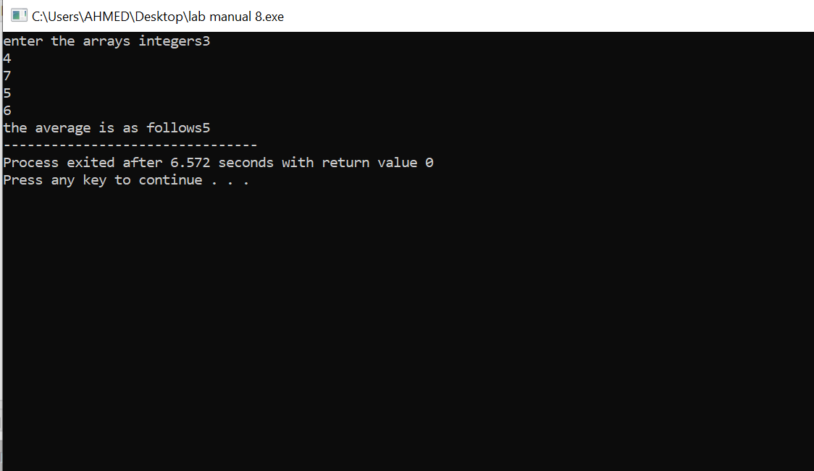

**Lab task 2**

int main(){

int arr[5];

int temp=0;

for(int i=0;i<=4;i++){

cin>> arr[i];

}

for(int n=0;n<=4;n++){

for(int j=0;j<4;j++){

if(arr[j]>arr[j+1]){

temp=arr[j];

arr[j]=arr[j+1];

arr[j+1]=temp;

}

}

} for (int a=0;a<=4;a++){

cout<< arr[a]<<" ";

}

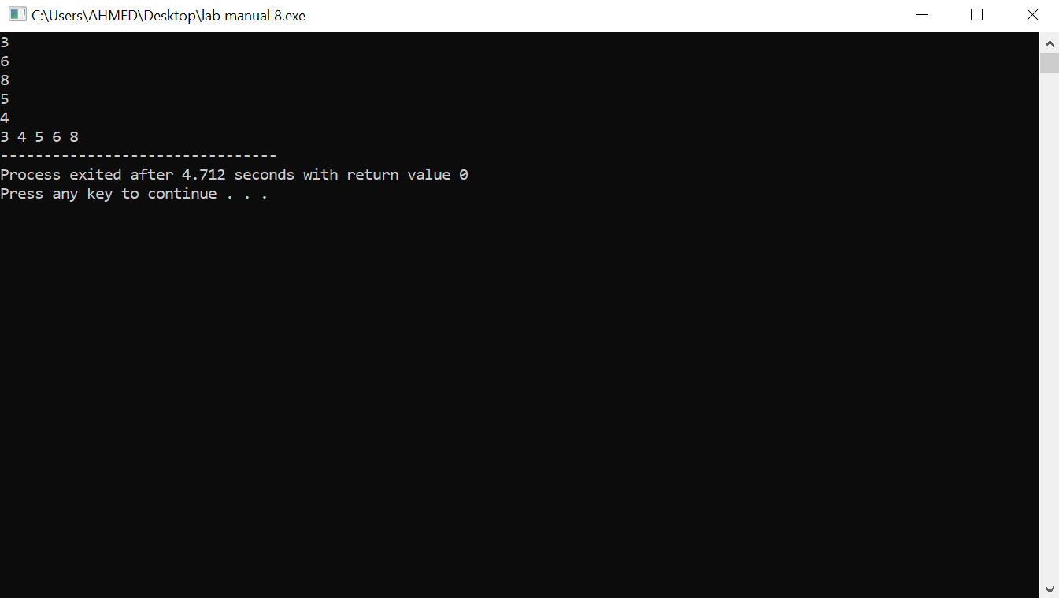

}

Lab task 3

int main() {

int n= 0;

int num[5];

int temp = 0;

int ind=0;

cout << "Enter the integers for the array";

for (int x =0;x<5;x++){

cin>>num[x];

}

for (int x =0;x<5;x++){

int smallest=x;

for (int y=n+1;y<5;y++) {

if (num[y]<num[smallest]) {

smallest = y;}

}

temp=num[x];

num[x]=num[smallest];

num[smallest]=temp;

n +=1;

}

cout<<"your array is as follows"<<endl;

for(int z=0;z<5;z++){

cout<<num[z]<<endl;

}

return 0;

}

